I. Container Deployment

- We have this web application, and we want to deploy it into a node.

- Suppose we have VM with 8GB RAM, 4 cores, inside we deploy container version 1.0.

- If we have more users visiting our application, then we need to scale so here we create another node (same version 1.0) -> now we need 2 nodes (16GB, 8 cores).

- If we want to update application to version 2.0 without downtime, we need to deploy container version 2.0 -> now we need 3 nodes (24GB, 12 cores) -> then we destroy container version 1.0

=> So insane (crazy)!

- Therefore, containers couldn’t communicate with each other, auto scaling wasn’t possible.

II. Kubernetes

- Take a single node -> fill the node with as many pods -> we have multiple containers in one node, then kubernetes orchestration.

Application orchestration:

- Deploy and manage applications (containers).

- Scale up/down according demand.

- Zero downtime deployments.

- Rollbacks.

…

III. Kubernetes Architecture:

1. Cluster:

- Cluster is a set of nodes, node is Virtual/Physical machine.

- One cluster is made up with at least one master node, and then connected to it, you have a couple of worker nodes.

Worker nodes:

- Each node has a kubelet process running on it (kubelet is kubernetes process that makes it possible for the cluster to communicate to each other and execute some tasks on those nodes like running application process).

- Each worker node has containers of different applications deployed on it, so depending how the workload is distributed you would have different number of containers running on worker nodes.

- Using more resources (because running applications).

Master node:

- Runs several kubernetes process to run and manger the cluster properly.

- Using less resources.

|  |  |
| --- | --- |
| Master node |  |
| API server (entrypoint to K8S cluster/cluster gateway) | This is process which different k8s clients with talk to (UI/API/CLI - kubectl) |
| Controller manager | Keeps track of whats happening in the cluster (container died, …) |
| Scheduler | Start application pod in worker node without randomly, instead it compute resource and assign to work node rely workload. |
| Etcd (key value store/cluster brain) | Cluster changes get stored in the key value store.  Example:  - What resources are available?  - Did the cluster state change?  - Is the cluster healthy? (query request from api server)  -> All information is stored etcd. But application data is NOT stored in etcd, it stored in worker node. |

- Kubernetes cluster usually have multiple master node, in case api server is load balanced (basic k8s cluster have 2 master nodes (one is backup because if master node died, you can’t access to the cluster, 3 worker nodes).

- Master node and worker nodes talk to each other is virtual network.

IV. Kubernetes Components:

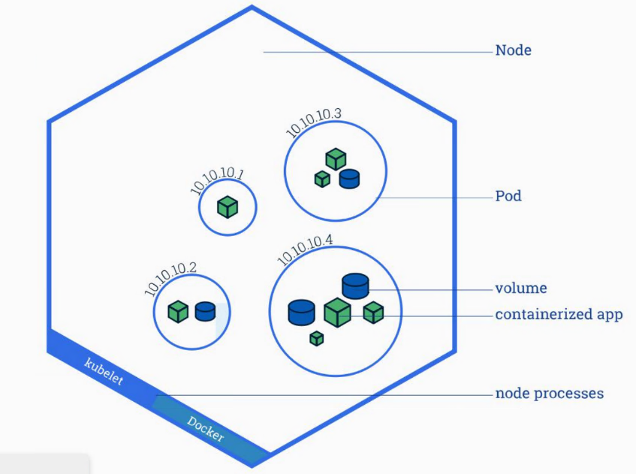

1. Node and Pod:

- Pod is smallest unit in K8S (abstraction of container), pods can be scheduled (deploying) to a node.

- Usually 1 application per Pod, but a pod can host more than one container -> a pod can be thought of as a container of containers.

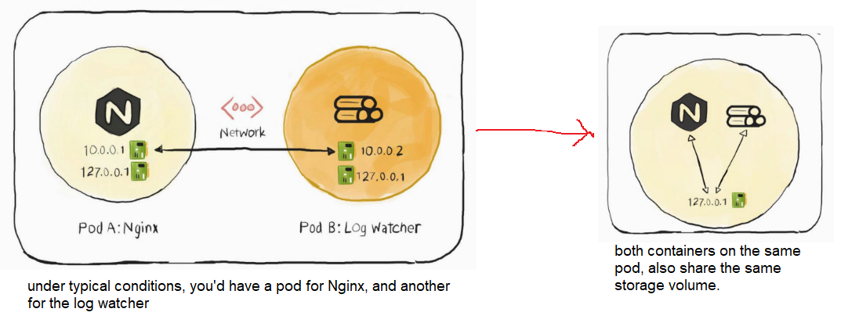

- Each Pod gets its own IP address.

- 2 Pod talk to each other using IP address, such as application and database but it’s ephemeral (not long-term). Because when we restart Pod (because application crash, out of resources, …) -> new IP address on re-creation -> application can’t connect to database.

2. Service and Ingress:

- Service is static IP (permanent IP) -> if Pod died, the service will stay, so we don’t need change the endpoint.

- Ingress is using domain name instead ip and port (request to ingress -> service -> pod), route traffic into cluster. Here illustration between **External Service** versus **Ingress**:

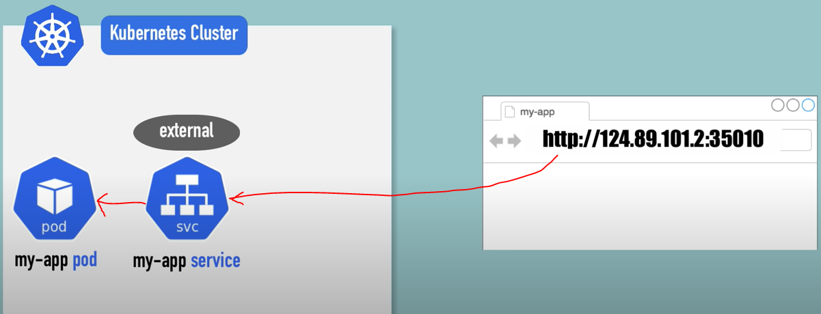

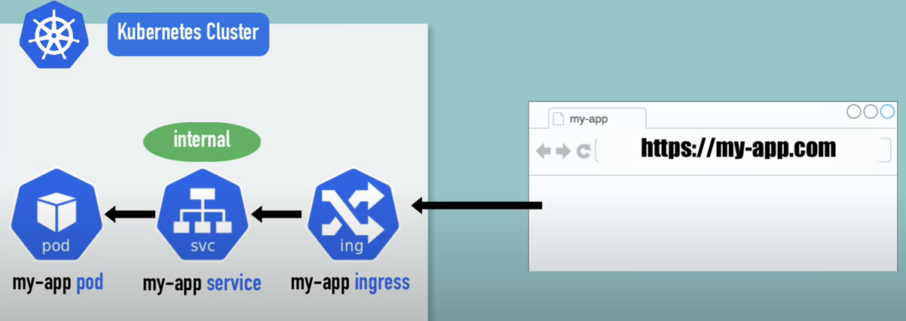

Example YAML file:

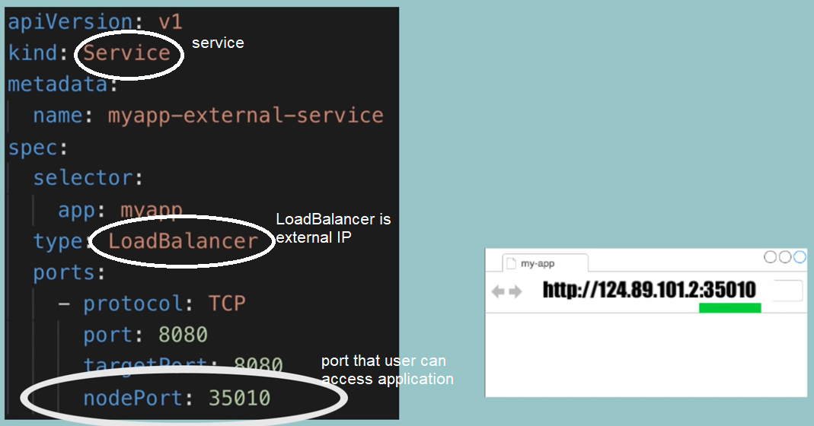

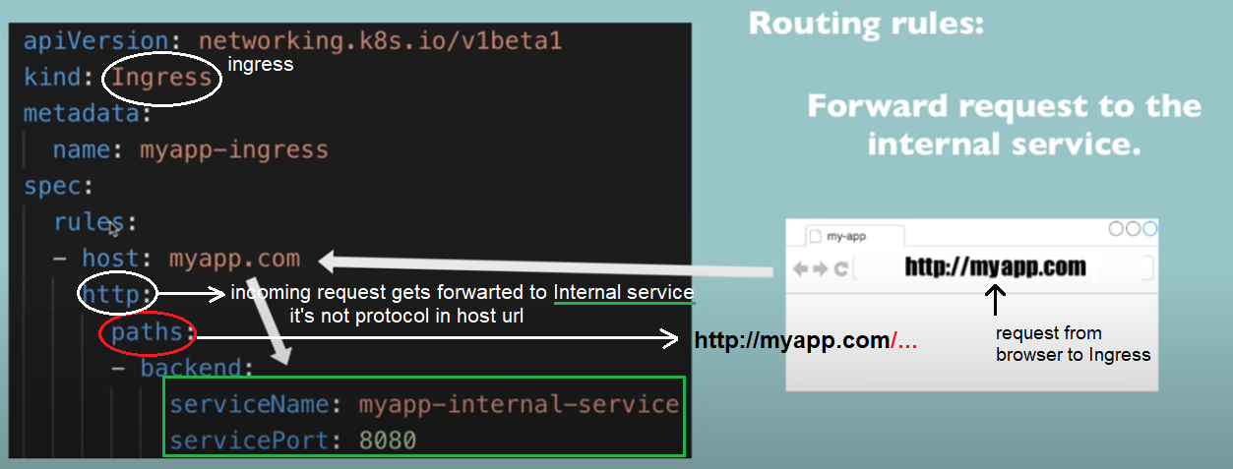

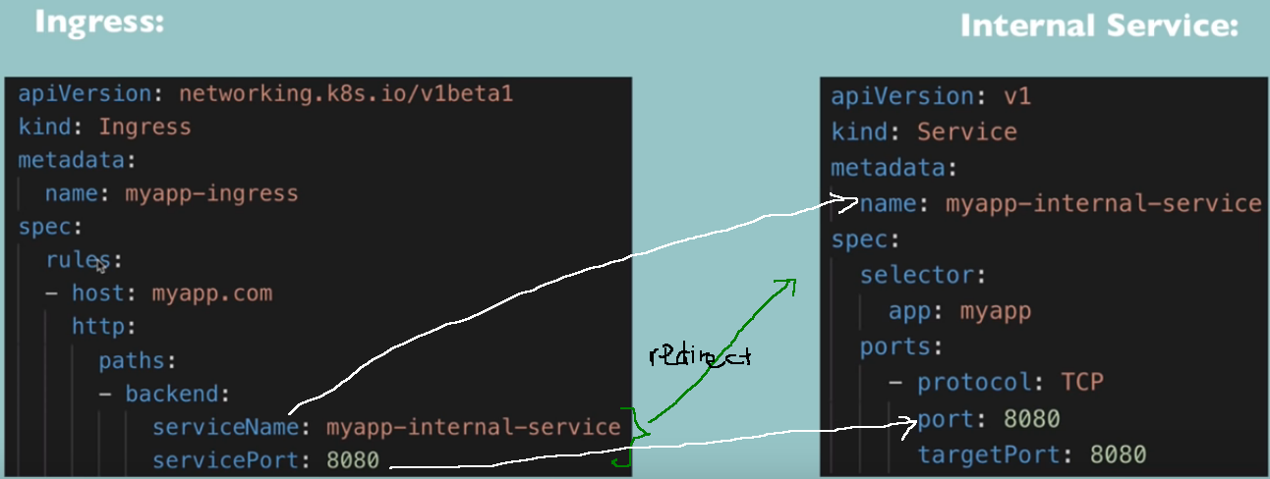We need use **Ingress Controller** to implement Ingress, such as **K8S Nginx Ingress Controller**.

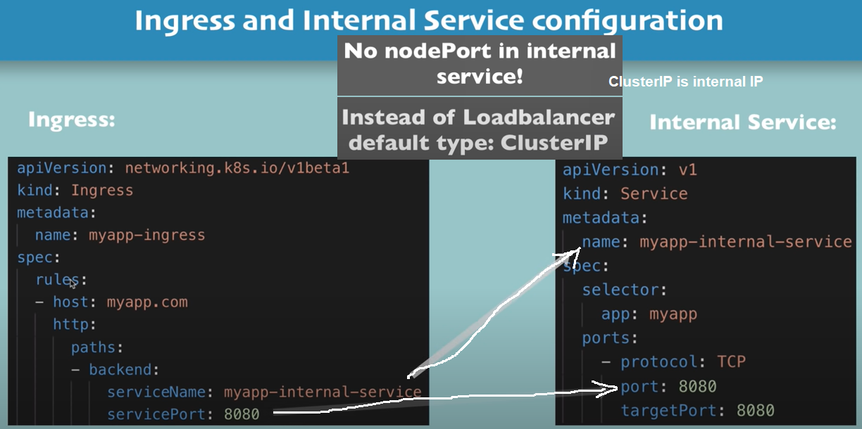

3. ConfigMap and Secret:

- We have an application with database endpoint, let’s say called “mongo-db-service”, that it uses to communicate with the database. If we changed database “mongo-db-service” to “mongo-db”, you would have to adjust database endpoint to “mongo-db”, then re-build, push, pull -> tedious because a little bit change.

- ConfigMap: external configuration of your application (such as: urls of database, some other services that you use, … ) -> Pod will gets data from ConfigMap. So if you change the name of services, you just adjust ConfigMap.

- ConfigMap stored information with plain text format -> insecure in case config database have username/password administrator. So we have Secret.

- Secret used to store secret data (base64) with credentials. You can use data from ConfigMap and Secret using environmental variables or as a properties file.

4. Volumes:

- Data is lost after restart pod.

- Volumes is attach a physical storage on hard drive to your pod, and that storage could be either on a local machine or remote (outside K8S Cluster).

- Local or remote storage think of storage as an external hard drive plugged in into the K8S Cluster, so K8S doesn’t manage data persistance.

5. Deployment and StatefulSet

- When running application on production, to avoid downtime application you will replica everything to running multiple applications on other same node. The replica is connected to the same Service (permanent IP).

- You don’t need create another pod, you will define blueprint for Pods (specify how many replicas you want to have) -> it’s deployments (abstraction of Pods).

- You can’t replica database pod using deployment because database has a state. So if replica database pod -> we would all need access the same shared data storage to avoid data inconsistent -> It’s Stateful.

- Any other stateful applications or databases should be created using statefulsets, not deployments.

-> Using Deployment for StateLESS apps, using StatefulSet for StateFul Apps or Database. So using StatefulSet not easy, so Database often hosted outside of K8S cluster.

6. Namespace:

- A namespace is a virtual cluster inside a cluster.

- If everything in one Namespace -> too many components (deployments, replicasets, services, … ) -> no overview -> group by namespace, example:

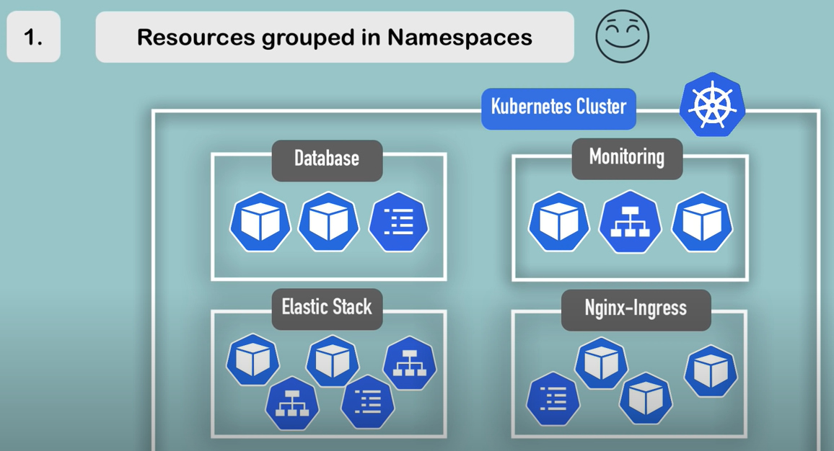

- Avoid conflicts when we have many teams, same application name but different configuration.

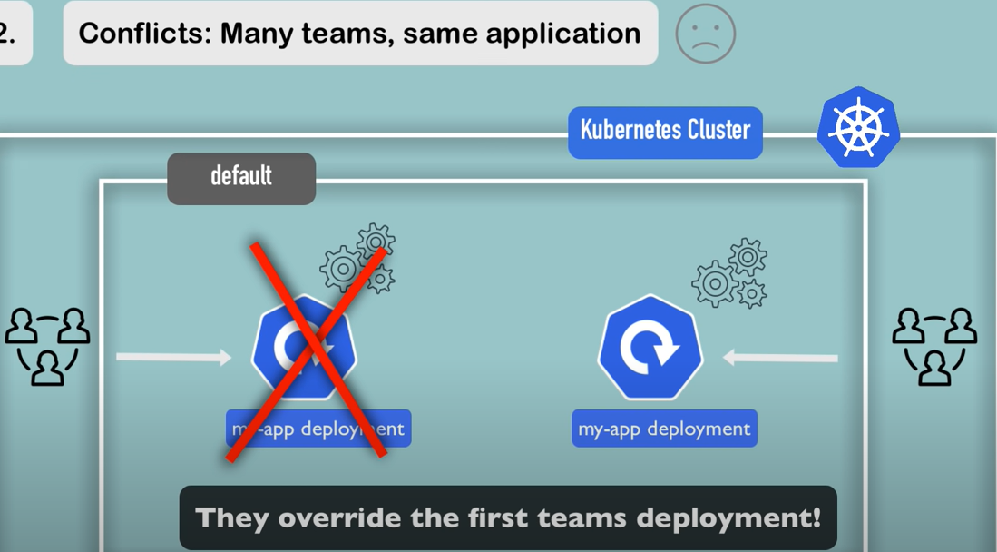

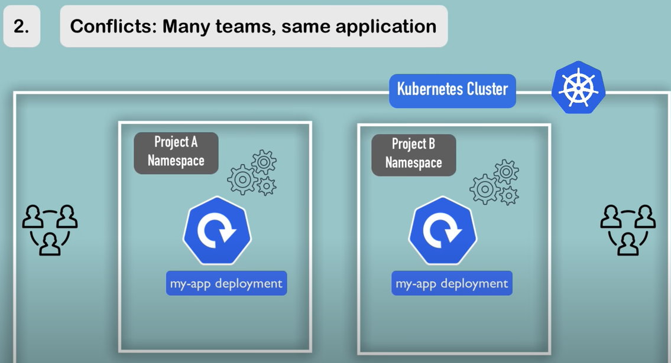

- Resource sharing: between 2 environment such as staging versus development, 2 environment can be in a cluster.

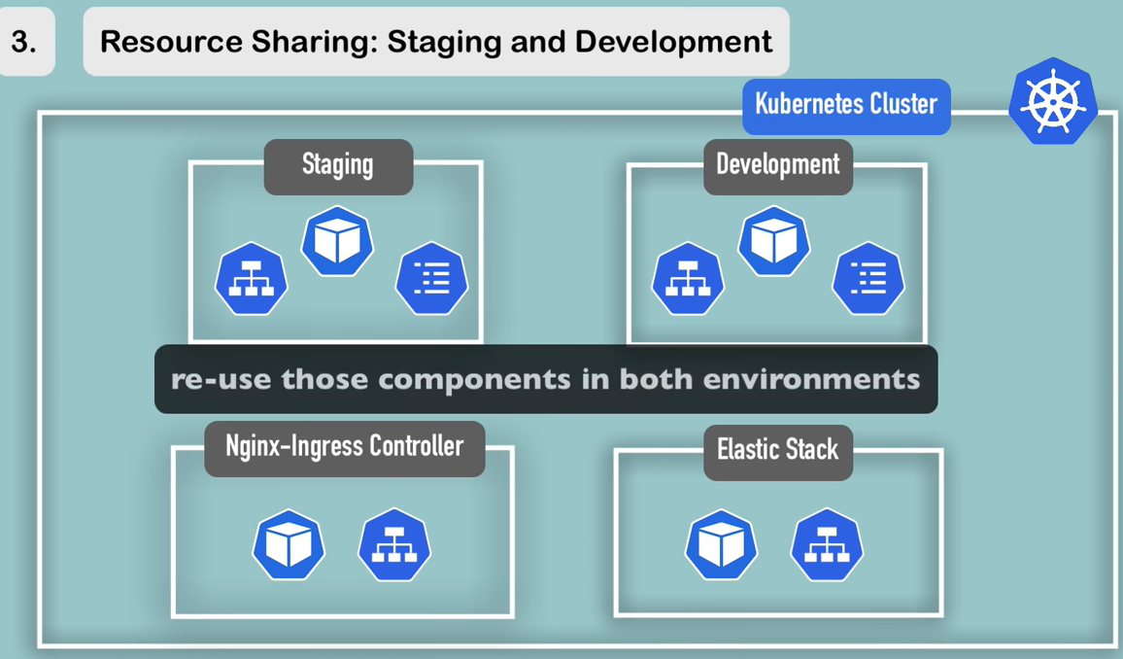

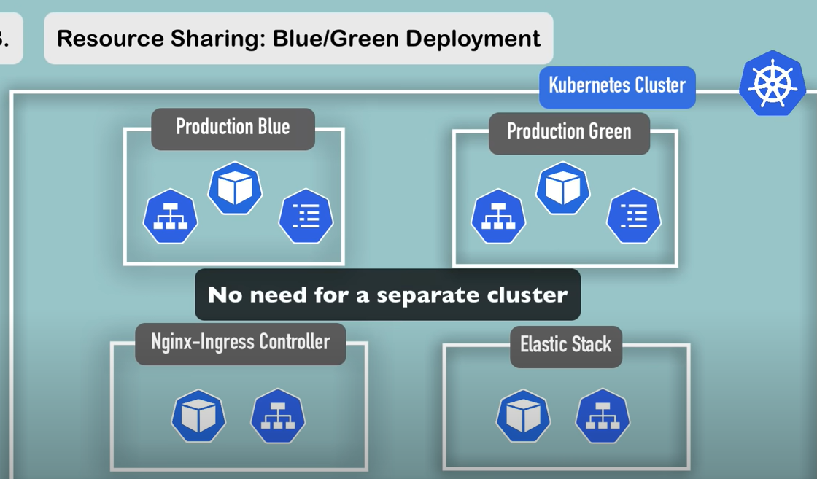

- But you need limit the resources (CPU, RAM, Storage) and access on each namespaces when you’re working multiple teams. Because 2 namespaces in one cluster, so multiple teams will use shared resources, if one team use too much resources, then other teams will have much less -> their applications may not scheduled because the cluster will run out of the resources.

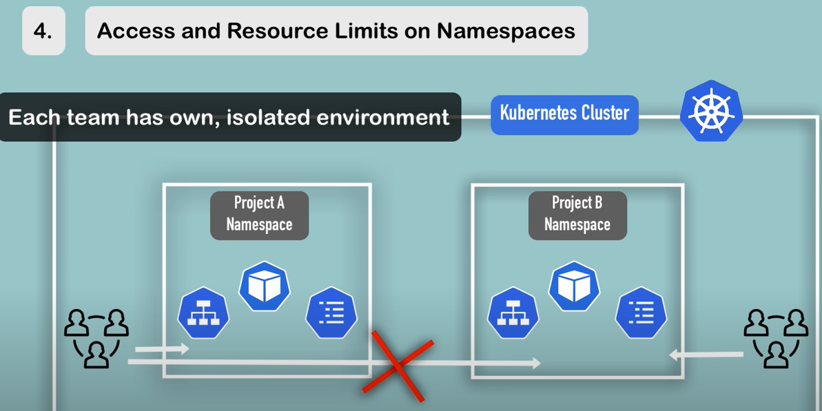

- Characteristics of namespace:

You can’t access most resources from another Namespace. If you have a ConfigMap in ProjectA namespace, that references the database service, you can’t use ConfigMap in ProjectB namespace.

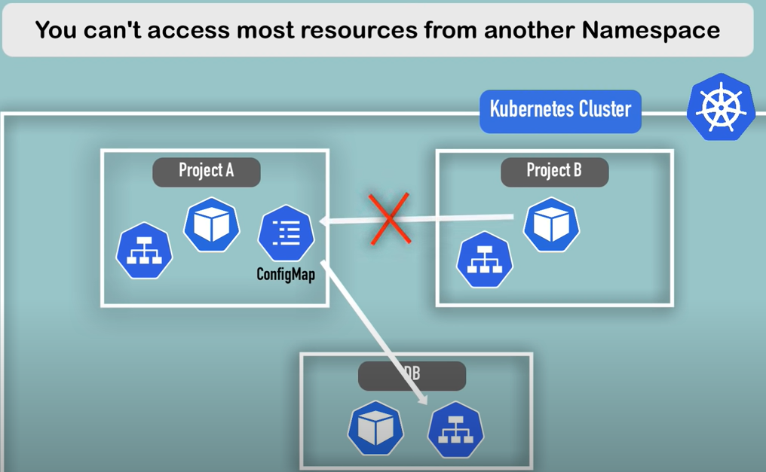

But instead you will have to create the same ConfigMap that also references the database service.

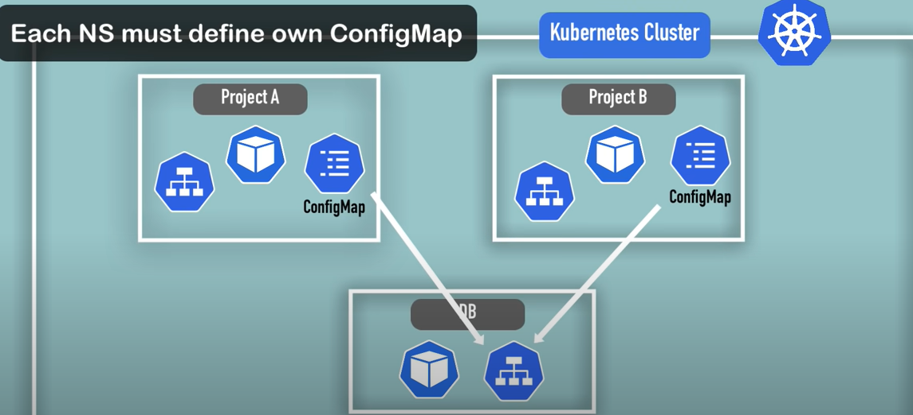

However, a resource that you can share across namespaces is **Service**.

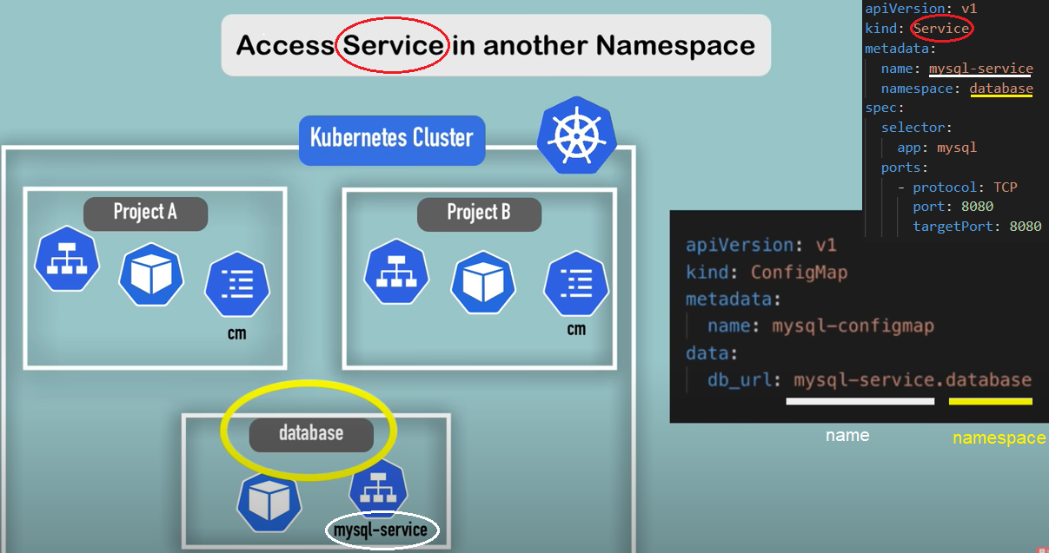

- Change active namespace -> $ kubens “name_of_namespace”

(<https://github.com/ahmetb/kubectx>)

V. Kubernetes Configuration:

3 Parts

- Metadata

- Specification

- Status -> etcd holds the current status of any K8S component.

VI. Minikube and Kubectl:

- Minikube CLI -> for start up/deleting the cluster

- Kubectl CLI -> for configuring the Minikube cluster

VII. Demo.

-> Database

1. ConfigMap:

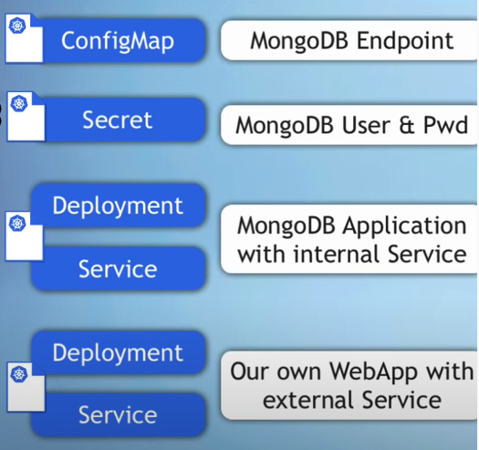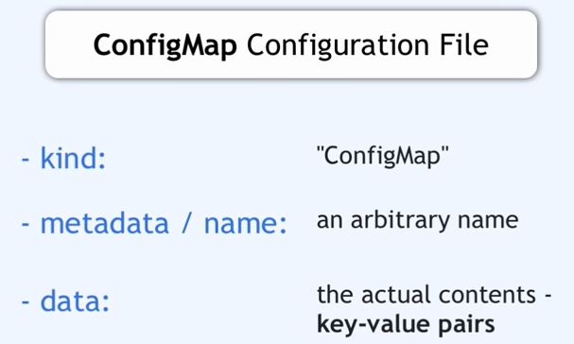

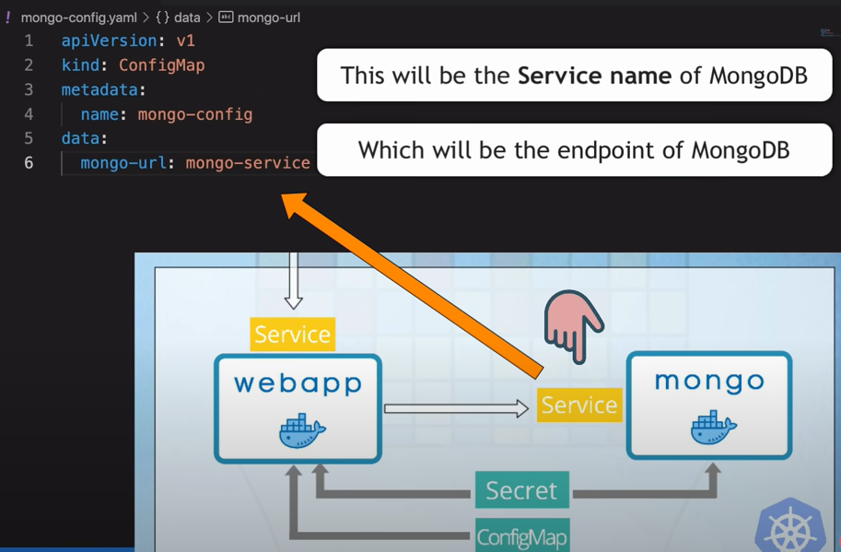

2. Secret:

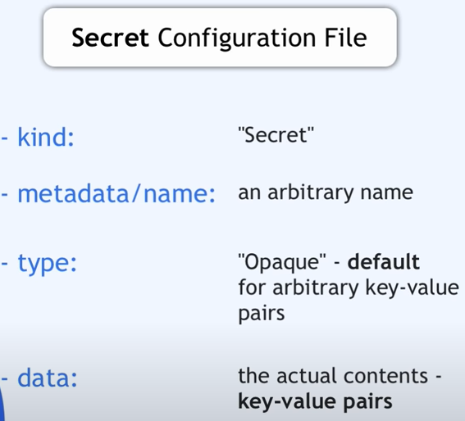

$ echo –n [str] | base64 -> fill to data:

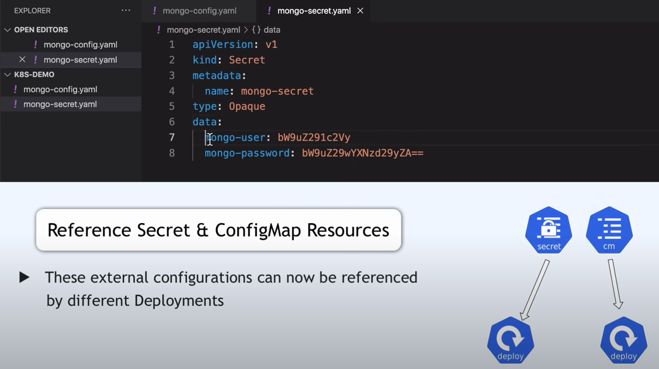

3. Deployment, Service -> same file because they belong together, you also can separate into 2 files but it isn’t very common.

- Deployment:

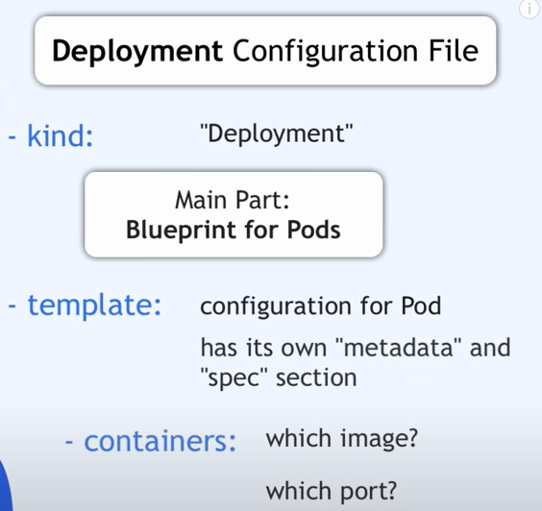

- labels / selectors - matchLabels:

labels -> are key/value pairs that are attached to objects, such as pods. Each object can have a set of key/value labels defined. Each key must be unique for a given object.

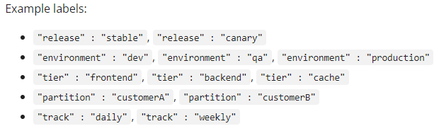

When we have multiple replicas of the same Pod, each pod will get a unique name:

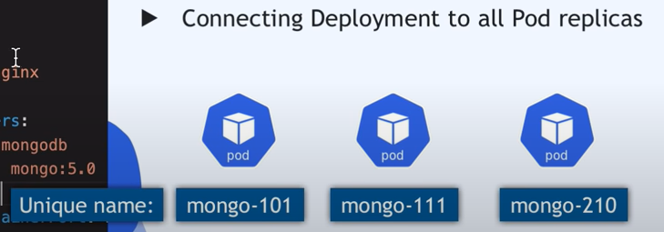

However, they can share the same label, so we can identify all the part replicas of the same application using a specific label that all of them share:

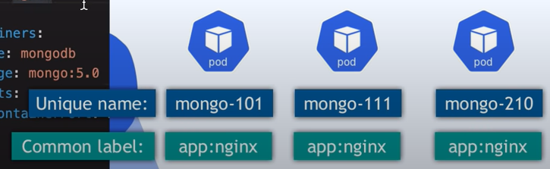

selectors -> core grouping primitive in Kubernetes.

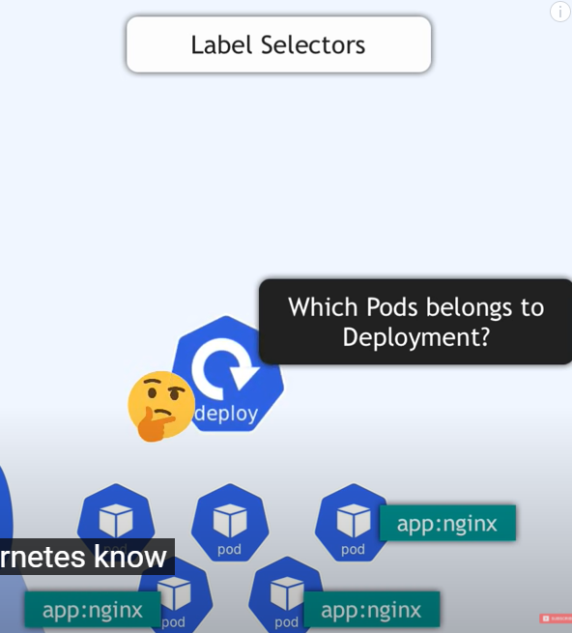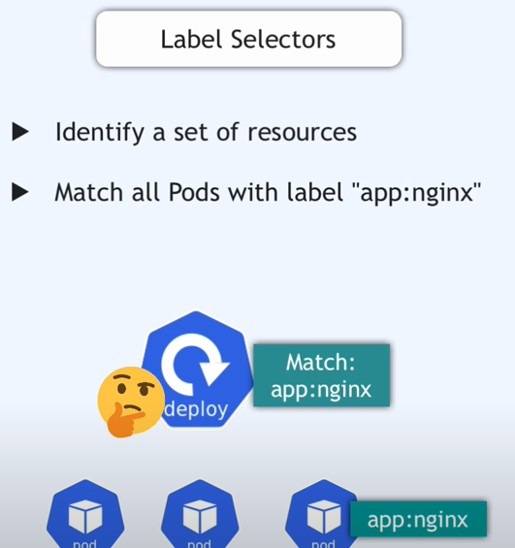

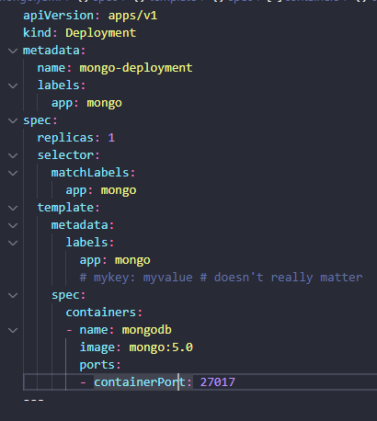

- Service:

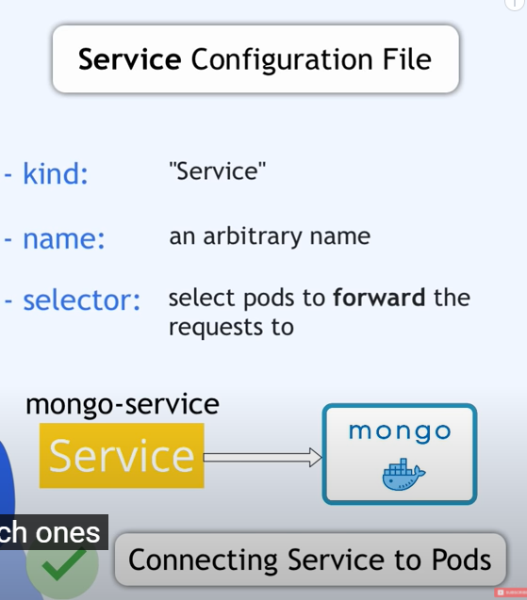

How does service know which pods belong to it? -> It’s selector, should matched selector in Deployment -> service and pods will find each other.

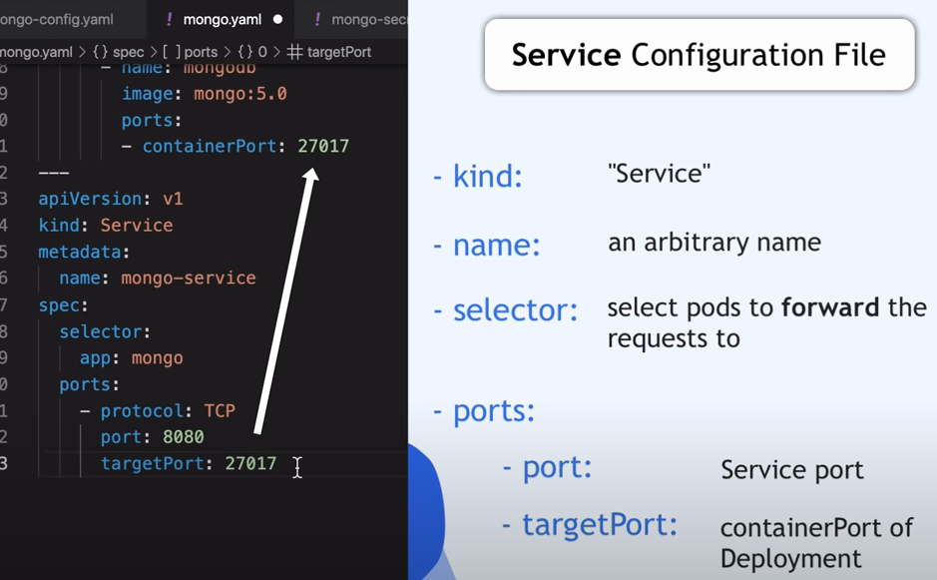

port -> port of service.

targetPort -> which port it should forward the request to the pods ~ same containerPort.

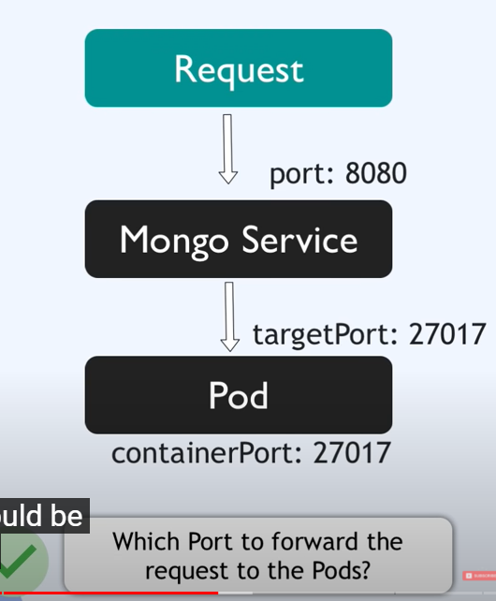

? How to pass secret and ConfigMap into pods

We need to configure username/password in database when startup -> set environment variables -> something like below:

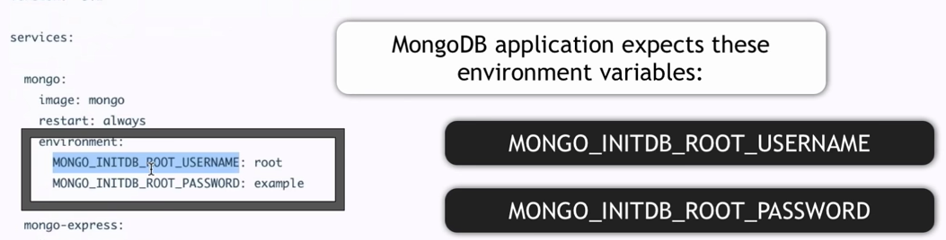

We can hardcore value:

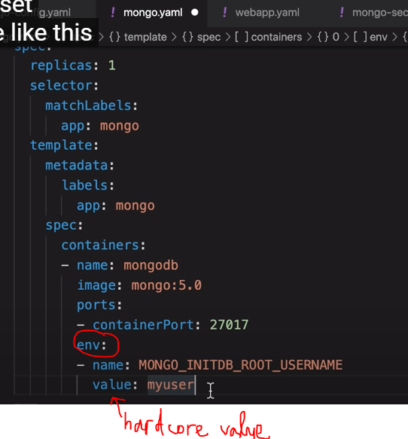

But in this case, we are going to reference from Secret and ConfigMap (external), so we are using `valueFrom`:

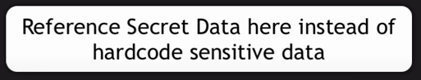

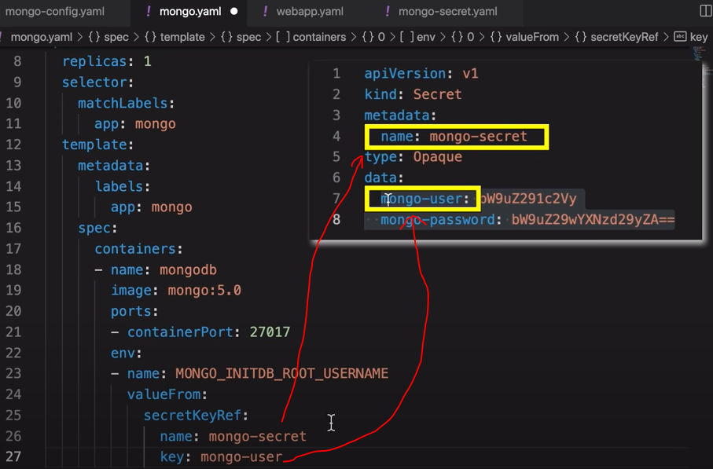

Similarity, we have:

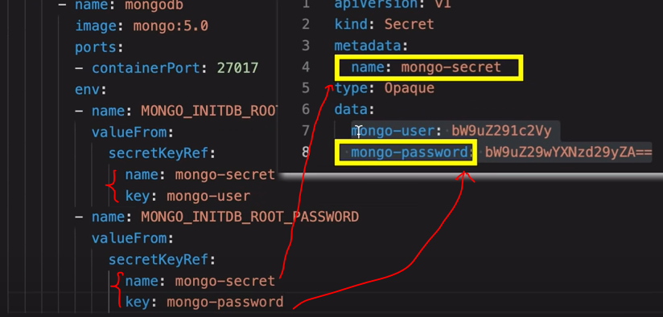

-> Web application (webapp)

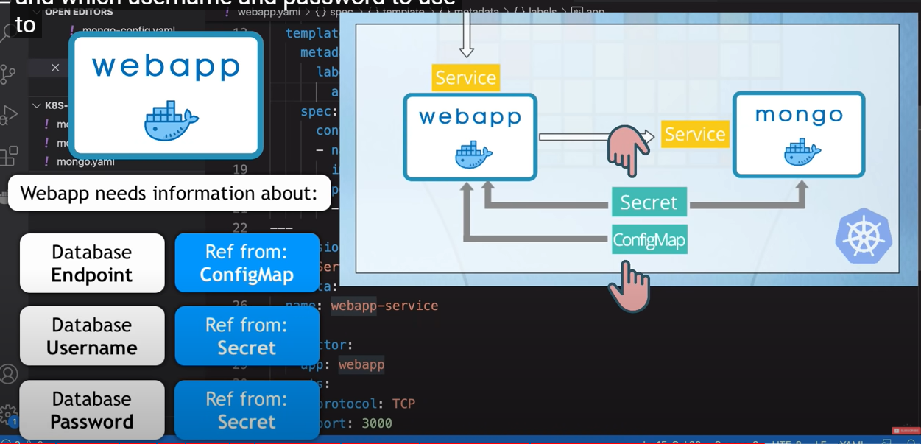

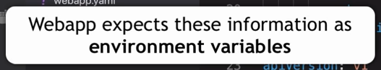

If you need the same information in 10 applications, you create Secret or ConfigMap once, and reference 10 times.

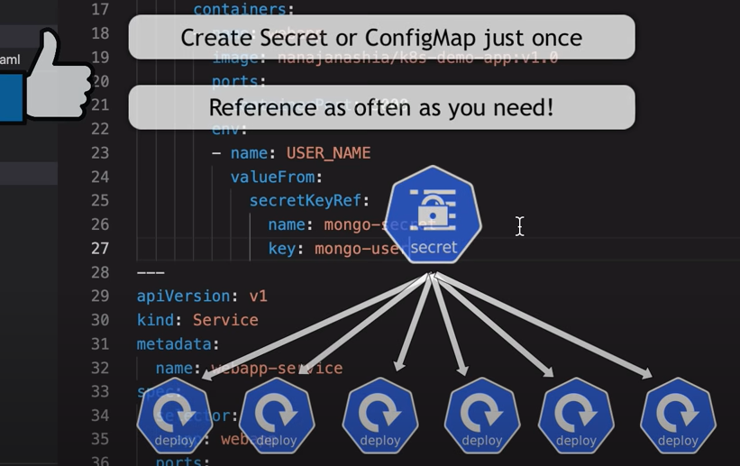

So we have environment variables for webapp (username and password reference from Secret, database reference from ConfigMap).

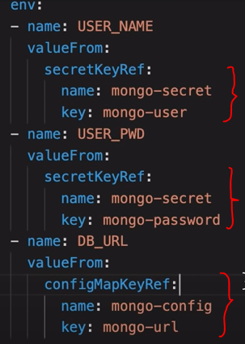

- Configuration external service:

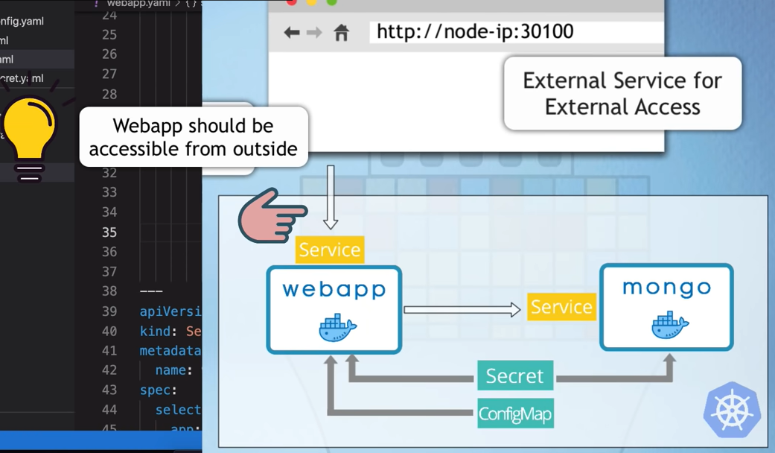

So we will configure Service of webapp:

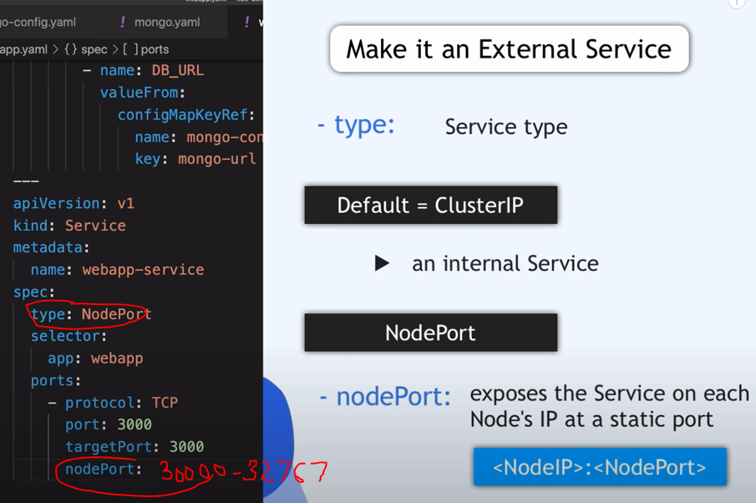

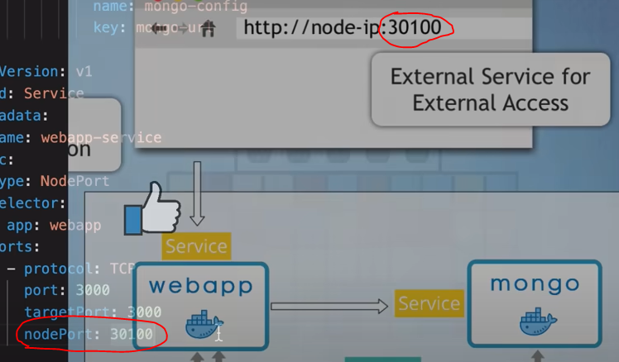

-> Abstraction:

